[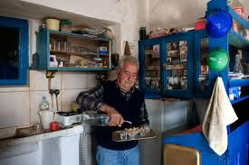](http://www.google.gr/imgres?hl=el&sa=X&tbas=0&biw=1819&bih=944&tbm=isch&tbnid=dANEuDu1hGKObM:&imgrefurl=http://www.karmanor.gr/index.php?mid=2&lid=1&aid=39&docid=PkeIlEOCD-L7sM&imgurl=http://www.karmanor.gr/userfiles/image/N0347.jpg&w=600&h=400&ei=K_x3UOWEF4jotQa9yoDIBA&zoom=1&iact=hc&vpx=186&vpy=330&dur=388&hovh=183&hovw=275&tx=125&ty=113&sig=104790312333497293790&page=1&tbnh=143&tbnw=210&start=0&ndsp=39&ved=1t:429,r:16,s:0,i:111)

**60**

[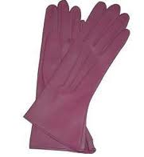](http://www.google.gr/imgres?hl=el&biw=1819&bih=944&tbs=itp:clipart&tbm=isch&tbnid=Pbt0wW4hSqNs-M:&imgrefurl=http://www.fashion-icon.gr/accessories/gantia-min-afinete-apotipomata-mono-aristes-entiposis/&docid=iOQp2-OPQ7MAAM&imgurl=http://www.fashion-icon.gr/wp-content/uploads/2009/12/%25CE%2594%25CE%25B5%25CF%2581%25CE%25BC%25CE%25AC%25CF%2584%25CE%25B9%25CE%25BD%25CE%25B1-%25CE%25B3%25CE%25AC%25CE%25BD%25CF%2584%25CE%25B9%25CE%25B11.JPG&w=227&h=245&ei=fPt3UPD3G8qytAatlIE4&zoom=1&iact=hc&vpx=314&vpy=184&dur=548&hovh=196&hovw=181&tx=92&ty=136&sig=104790312333497293790&page=1&tbnh=141&tbnw=130&start=0&ndsp=50&ved=1t:429,r:1,s:0,i:70)[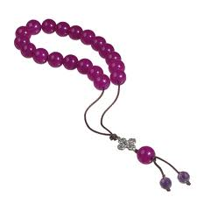](http://www.google.gr/imgres?hl=el&biw=1819&bih=944&tbs=itp:clipart&tbm=isch&tbnid=33_eieQOIufGHM:&imgrefurl=http://www.finegems.gr/el/products/kompoloi-5&docid=kdJFRfoUOZYWFM&imgurl=http://www.finegems.gr/sites/default/files/styles/gallery-istorikobig/public/71187_0.png&w=800&h=800&ei=R_p3UIXJO4HZtAbN2IDwDA&zoom=1&iact=hc&vpx=915&vpy=356&dur=1330&hovh=225&hovw=225&tx=83&ty=105&sig=104790312333497293790&page=1&tbnh=143&tbnw=153&start=0&ndsp=51&ved=1t:429,r:16,s:0,i:129)[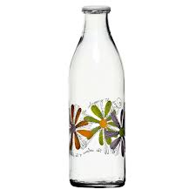](http://www.google.gr/imgres?num=10&hl=el&sa=X&biw=1819&bih=944&tbs=itp:clipart&tbm=isch&tbnid=JGPtGI_X3FGb_M:&imgrefurl=http://www.hpmylonas.gr/-gyalina-eidi/1160-boukali-nerou-himou-poma-gialino-sxedia.html&docid=9TQgEP_qe-9QIM&imgurl=http://www.hpmylonas.gr/1160-1444-thickbox/boukali-nerou-himou-poma-gialino-sxedia.jpg&w=600&h=600&ei=Kvp3UO6_F4bOsgbByIDgCg&zoom=1&iact=hc&vpx=537&vpy=604&dur=638&hovh=225&hovw=225&tx=107&ty=146&sig=104790312333497293790&page=1&tbnh=145&tbnw=146&start=0&ndsp=48&ved=1t:429,r:10,s:20,i:160)

[](http://www.google.gr/imgres?hl=el&sa=X&tbas=0&biw=1819&bih=944&tbm=isch&tbnid=gDqbS7-RKSuMyM:&imgrefurl=http://mourlia.pblogs.gr/tags/litsa-gr.html&docid=sURju6BsxbW2JM&imgurl=http://mourlia.pblogs.gr/files/f/332877-%25CE%25AC%25CE%25B4%25CE%25B5%25CE%25B9%25CE%25B1%2520%25CF%2584%25CF%2583%25CE%25AD%25CF%2580%25CE%25B7.jpg&w=400&h=223&ei=rvt3UJeTEYWPswbL44DYBQ&zoom=1&iact=hc&vpx=195&vpy=165&dur=596&hovh=167&hovw=301&tx=172&ty=118&sig=104790312333497293790&page=1&tbnh=142&tbnw=254&start=0&ndsp=40&ved=1t:429,r:0,s:0,i:63)[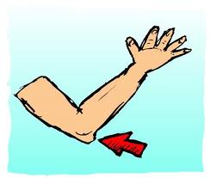](http://www.google.gr/imgres?hl=el&biw=1819&bih=944&tbs=itp:clipart&tbm=isch&tbnid=tlBi6LmuJvxK6M:&imgrefurl=http://meacolpa.blogspot.com/2010/06/blog-post_2263.html&docid=KXEtiBmYVj5KXM&imgurl=http://img153.imageshack.us/img153/811/url4375662.jpg&w=425&h=361&ei=mfp3UOKmJoLPtAaiv4HwBg&zoom=1&iact=hc&vpx=702&vpy=330&dur=665&hovh=207&hovw=244&tx=125&ty=119&sig=104790312333497293790&page=1&tbnh=139&tbnw=162&start=0&ndsp=51&ved=1t:429,r:12,s:0,i:103)[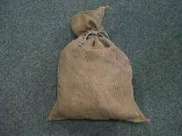](http://www.google.gr/imgres?hl=el&biw=1819&bih=944&tbm=isch&tbnid=sn4MSqu7u_GvfM:&imgrefurl=http://greece-salonika.blogspot.com/2010/10/blog-post_5198.html&docid=O7y9LcvWSgQGQM&imgurl=http://3.bp.blogspot.com/_OPg-Kn4CzDg/TKch14mOtzI/AAAAAAAAXBc/rZXDwzCNUIQ/s400/imagesCAZOSR4F.jpg&w=259&h=194&ei=0Pt3UM6XMcnNtAbRxYH4CQ&zoom=1&iact=hc&vpx=658&vpy=173&dur=3199&hovh=155&hovw=207&tx=109&ty=77&sig=104790312333497293790&page=1&tbnh=146&tbnw=187&start=0&ndsp=41&ved=1t:429,r:3,s:0,i:72)[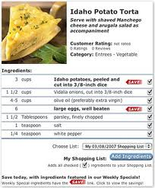](http://www.google.gr/imgres?start=211&hl=el&biw=1819&bih=944&tbm=isch&tbnid=421NjWtJZb6hFM:&imgrefurl=http://www.harpsfood.com/Notifications/Notice_Features_S.las?-token.S=42FT9R944CB1138P7d212511wXTN6L52550524%7C68203%7C1007060751%7C%7C%7C&docid=GDCluGfOqY5yyM&imgurl=http://harps.graphics.grocerywebsite.com/GraphicsFeatures/Recipes_detail_300.jpg&w=300&h=362&ei=0_13UJH3OYbZsgbT0YFY&zoom=1&iact=hc&vpx=599&vpy=513&dur=3100&hovh=247&hovw=204&tx=87&ty=147&sig=104790312333497293790&page=5&tbnh=139&tbnw=115&ndsp=55&ved=1t:429,r:60,s:200,i:184)[](http://www.google.gr/imgres?hl=el&sa=X&biw=1819&bih=944&tbs=itp:clipart&tbm=isch&tbnid=jNm2F6ZVFPOJaM:&imgrefurl=http://www.e-selides.gr/color_image/92,%CE%86%CE%B3%CE%B3%CE%B5%CE%BB%CE%BF%CF%82_2&docid=Gb-qgYV4LpkZ3M&imgurl=http://www.e-selides.gr/images/photos_galleries_b/normal/1346702104_n.jpg&w=600&h=815&ei=A_x3UPbOJ4XXtAb2ioDQCQ&zoom=1&iact=hc&vpx=537&vpy=579&dur=1555&hovh=262&hovw=193&tx=141&ty=147&sig=104790312333497293790&page=1&tbnh=129&tbnw=95&start=0&ndsp=47&ved=1t:429,r:11,s:20,i:163)[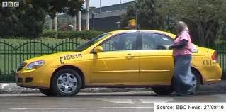](http://www.google.gr/imgres?start=199&hl=el&biw=1819&bih=944&tbm=isch&tbnid=wTrQTo9Z04xMoM:&imgrefurl=http://worldstreets.wordpress.com/2010/09/28/on-the-road-with-one-of-cairos-first-female-taxi-drivers/&docid=oZ0YsdVnMF9dFM&imgurl=http://worldstreets.files.wordpress.com/2010/09/egypt-female-taxi-driver.jpg&w=572&h=284&ei=ePx3UJGPCcW0tAbToYHADw&zoom=1&iact=hc&vpx=1011&vpy=271&dur=1800&hovh=158&hovw=319&tx=223&ty=105&sig=104790312333497293790&page=5&tbnh=134&tbnw=268&ndsp=50&ved=1t:429,r:4,s:200,i:16)