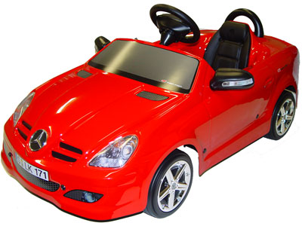[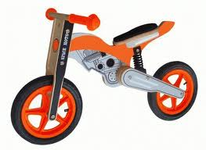](http://www.google.gr/imgres?q=toys&start=99&hl=el&gbv=2&biw=1920&bih=879&addh=36&tbs=itp:clipart&tbm=isch&tbnid=1XKJoZx6RTuEkM:&imgrefurl=http://www.tradekool.com/products/1636254/Wooden-Toys.html&docid=qQ0j_mOqEob63M&imgurl=http://images.tradekool.com/159869500/Wooden-Toys.jpg&w=508&h=371&ei=3JdTT_LHOsO6hAe5saGBDA&zoom=1)[](http://www.google.gr/imgres?q=toys&start=99&hl=el&gbv=2&biw=1920&bih=879&addh=36&tbs=itp:clipart&tbm=isch&tbnid=FPtLCpYL1F8cpM:&imgrefurl=http://www.yeskey.com/space/Weijun145/products_info/Baby-Soft-Toy-5011-1240.html&docid=8GVpjIkj5cD0CM&imgurl=http://www.yeskey.com/uploadfile/w5/Weijun145/product/baby-soft-toys/Baby-Soft-Toy-5011-1278304528-0.jpg&w=360&h=360&ei=3JdTT_LHOsO6hAe5saGBDA&zoom=1)[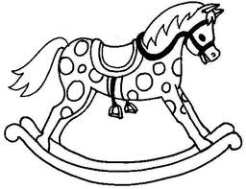](http://www.google.gr/imgres?q=toys&hl=el&gbv=2&biw=1920&bih=879&tbs=itp:clipart&tbm=isch&tbnid=uF6XA_rmcs-mdM:&imgrefurl=http://ngfl.northumberland.gov.uk/clipart/Toys/pages/rocking%20horse_jpg.htm&docid=iprye6PuMb_rsM&imgurl=http://ngfl.northumberland.gov.uk/clipart/Toys/images/rocking%2520horse_jpg.jpg&w=540&h=417&ei=qJdTT8LFO_HP4QS0sNmqDQ&zoom=1)C:\WINDOWS\Application Data\Microsoft\Media Catalog\Downloaded Clips\cl2d\j0113368.wmfd3ix3weo[1]C:\WINDOWS\Application Data\Microsoft\Media Catalog\Downloaded Clips\cl56\j0215303.wmfC:\WINDOWS\Application Data\Microsoft\Media Catalog\Downloaded Clips\cl56\j0215303.wmfC:\WINDOWS\Application Data\Microsoft\Media Catalog\Downloaded Clips\cl56\j0215303.wmfC:\WINDOWS\Application Data\Microsoft\Media Catalog\Downloaded Clips\cl0\SO01901_.wmfC:\WINDOWS\Application Data\Microsoft\Media Catalog\Downloaded Clips\cl0\SO01901_.wmfC:\WINDOWS\Application Data\Microsoft\Media Catalog\Downloaded Clips\cl0\SO01901_.wmf

[](http://www.google.gr/imgres?q=cloths&hl=el&gbv=2&biw=1920&bih=879&tbs=itp:clipart&tbm=isch&tbnid=8rrWQSbD7SHuGM:&imgrefurl=http://www.formatmag.com/news/play-cloths-hooded-varsity-jacket/&docid=GZA9xDK0kmSFhM&imgurl=http://www.formatmag.com/wp-content/uploads/2010/12/play-cloths-hooded-varsity-1-570x380.jpg&w=570&h=380&ei=o5hTT8vXAsi0hAe6oMjFBA&zoom=1)[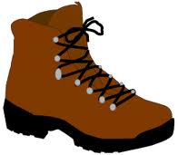](http://www.google.gr/imgres?q=cloths&start=94&hl=el&gbv=2&biw=1920&bih=879&addh=36&tbs=itp:clipart&tbm=isch&tbnid=q8MeGhcGXfH-LM:&imgrefurl=http://graphics-warehouse.com/pages/cloths.html&docid=Fi8BGpXSzi1NyM&imgurl=http://graphics-warehouse.com/lib_04/00000768.gif&w=246&h=214&ei=xJhTT4LrNMfNhAen5oXSCw&zoom=1)[](http://www.google.gr/imgres?q=cloths&start=94&hl=el&gbv=2&biw=1920&bih=879&addh=36&tbs=itp:clipart&tbm=isch&tbnid=tlFTUmcyx7pEiM:&imgrefurl=http://www.hypequest.com/play-cloths-holiday-2008-available-now-black-rainbow/&docid=JvZESkE55tXEUM&imgurl=http://www.hypequest.com/media/big_six_jean_001.jpg&w=800&h=800&ei=xJhTT4LrNMfNhAen5oXSCw&zoom=1)

[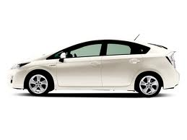](http://www.google.gr/imgres?q=means+of+transport&start=183&hl=el&gbv=2&biw=1920&bih=879&addh=36&tbs=itp:clipart&tbm=isch&tbnid=BpeMdxjwW4XIlM:&imgrefurl=http://fit-zaang.com/2011/05/23/monday-self-argument-is-a-hybrid-vehicle-the-most-economical-means-of-transportation-for-the-average-family-a-debate/&docid=brP3shzqNaWxTM&imgurl=http://fitzaang.files.wordpress.com/2011/05/prius.jpg&w=640&h=480&ei=v5pTT--3MsW3hQfA0JXrCw&zoom=1)[](http://www.google.gr/imgres?q=means+of+transport&hl=el&gbv=2&biw=1920&bih=879&tbs=itp:clipart&tbm=isch&tbnid=QQiOJ_rZuUiNvM:&imgrefurl=http://youronlinenglishclass.com.pt/Quiz/transport/meansoftransport1.htm&docid=qCefCzqluI20BM&imgurl=http://youronlinenglishclass.com.pt/Quiz/transport/19.gif&w=640&h=480&ei=A5pTT5qROcLQhAeytNzaCw&zoom=1)[](http://www.google.gr/imgres?q=means+of+transport&hl=el&gbv=2&biw=1920&bih=879&tbs=itp:clipart&tbm=isch&tbnid=ws_NR1sK2SyMrM:&imgrefurl=http://uaeducation.com/pages/121&docid=cskcr6gtR4OAyM&imgurl=http://uaeducation.com/share/fceditor/editor/filemanager/connectors/php/images/taxi1.jpg&w=488&h=258&ei=A5pTT5qROcLQhAeytNzaCw&zoom=1)[](http://www.google.gr/imgres?q=means+of+transport+bus&hl=el&gbv=2&biw=1920&bih=879&tbs=itp:clipart&tbm=isch&tbnid=SNbLuAfDqgovpM:&imgrefurl=http://www.englishexercises.org/makeagame/viewgame.asp?id=3489&docid=3CCG3LAhbY6GUM&imgurl=http://www.englishexercises.org/makeagame/my_documents/my_pictures/gallery/b/bus.jpg&w=200&h=200&ei=65pTT4T1CseQ4gTB1-WTDg&zoom=1)[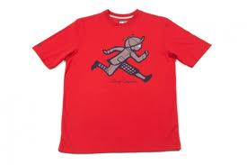](http://www.google.gr/imgres?q=cloths&hl=el&gbv=2&biw=1920&bih=879&tbs=itp:clipart&tbm=isch&tbnid=9YmwOlLC2_DNgM:&imgrefurl=http://www.freshnessmag.com/2010/02/13/play-cloths-spring-2010-collection-delivery-1/&docid=1GwfovwopOOSBM&imgurl=http://images.freshnessmag.com/wp-content/uploads/2010/02/play-cloths-spring-2010-collection-6-570x380.jpg&w=570&h=380&ei=o5hTT8vXAsi0hAe6oMjFBA&zoom=1)C:\WINDOWS\Application Data\Microsoft\Media Catalog\Downloaded Clips\cl2d\j0113272.wmfC:\WINDOWS\Application Data\Microsoft\Media Catalog\Downloaded Clips\cl24\j0090269.wmfC:\WINDOWS\Application Data\Microsoft\Media Catalog\Downloaded Clips\cl24\j0090269.wmfj0079004j0079004C:\Program Files\Common Files\Microsoft Shared\Clipart\cagcat50\TN00686_.wmfj0335794j0335794j0335794C:\WINDOWS\Application Data\Microsoft\Media Catalog\Downloaded Clips\cl2d\j0113368.wmf