[](http://www.google.gr/imgres?hl=el&sa=X&tbas=0&biw=1920&bih=944&tbm=isch&tbnid=8SJsbPBplnn6XM:&imgrefurl=http://www.newsnow.gr/article/141082/H-tsixla-vlaptei-ti-mnimi.html&docid=rGjxPIzoMmfi2M&imgurl=http://images.newsnow.gr/14/141082/H-tsixla-vlaptei-ti-mnimi-1-315x236.jpg&w=315&h=236&ei=SHaGUJyDGZHptQayh4CwBQ&zoom=1&iact=hc&vpx=194&vpy=548&dur=903&hovh=188&hovw=252&tx=151&ty=48&sig=104790312333497293790&page=1&tbnh=152&tbnw=204&start=0&ndsp=45&ved=1t:429,r:16,s:20,i:188)[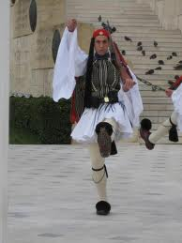](http://www.google.gr/imgres?hl=el&biw=1920&bih=944&tbm=isch&tbnid=3Cv7M5MQz_l68M:&imgrefurl=http://artagoni.pblogs.gr/tags/tsolias-gr.html&docid=CnOxTyAFqgIwOM&imgurl=http://artagoni.pblogs.gr/files/f/174871-K%C3%A1%C3%B1%C3%A4%C3%AF%C3%BD%C3%AB%C3%A5%C3%B2%20%C3%AA%C3%A1%C3%A9%20%C3%B4%C3%B3%C3%AF%C3%AB%C3%A9%C3%9C%C3%B2%20129.jpg&w=768&h=1024&ei=EXSGULKlD5Hesgbp-YDYDQ&zoom=1&iact=hc&vpx=617&vpy=112&dur=1191&hovh=259&hovw=194&tx=121&ty=121&sig=104790312333497293790&page=1&tbnh=129&tbnw=100&start=0&ndsp=54&ved=1t:429,r:3,s:0,i:72)[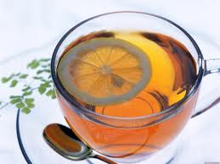](http://www.google.gr/imgres?hl=el&biw=1920&bih=944&tbm=isch&tbnid=24wxEBuRXe2t4M:&imgrefurl=http://www.pygmi.gr/%CF%85%CE%B3%CE%B5%CE%AF%CE%B1/%CF%84%CE%BF-%CF%84%CF%83%CE%AC%CE%B9-%CE%B5%CE%BB%CE%B9%CE%BE%CE%AE%CF%81%CE%B9%CE%BF-%CF%84%CE%B7%CF%82-%CE%B6%CF%89%CE%AE%CF%82/&docid=Lbk7od_azycH5M&imgurl=http://www.pygmi.gr/wp-content/uploads/2012/03/%CF%84%CF%83%CE%B1%CE%B9.jpg&w=1280&h=960&ei=WHSGULTxHYrXtAbrj4GgAw&zoom=1&iact=hc&vpx=733&vpy=190&dur=771&hovh=194&hovw=259&tx=151&ty=117&sig=104790312333497293790&page=1&tbnh=147&tbnw=208&start=0&ndsp=46&ved=1t:429,r:3,s:0,i:86)[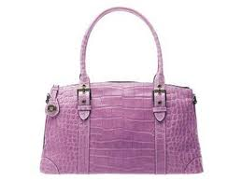](http://www.google.gr/imgres?num=10&hl=el&biw=1920&bih=944&tbm=isch&tbnid=eHAv9svtsnwvFM:&imgrefurl=http://korinthiannews.gr/?p=68823&docid=EdJPa47mrAV9WM&imgurl=http://korinthiannews.gr/wp-content/uploads/2012/06/%CF%84%CF%83%CE%AC%CE%BD%CF%84%CE%B1.jpg&w=400&h=300&ei=w3OGUIfkIMjMtAbK4IGoAQ&zoom=1&iact=hc&vpx=360&vpy=188&dur=566&hovh=194&hovw=259&tx=166&ty=78&sig=104790312333497293790&page=1&tbnh=144&tbnw=199&start=0&ndsp=50&ved=1t:429,r:1,s:0,i:83)

[](http://www.google.gr/imgres?hl=el&biw=1920&bih=944&tbs=itp:clipart&tbm=isch&tbnid=G7KzMEnZlkp2EM:&imgrefurl=http://www.meandhome.gr/prod/prosopfrontida/roley-boyrtses-mallion/boyrtsa-mallion-braun-me-tehnologia-ion/prod252604pp/&docid=qCdeGO7viTOQ4M&imgurl=http://www.meandhome.gr/MEDIA/content_CustomProductCatalog/m810159pp_Brush-0467464-550.jpg&w=550&h=400&ei=pXaGUKTKGdDKtAbX7ICADQ&zoom=1&iact=hc&vpx=190&vpy=189&dur=643&hovh=191&hovw=263&tx=196&ty=94&sig=104790312333497293790&page=1&tbnh=147&tbnw=207&start=0&ndsp=48&ved=1t:429,r:0,s:0,i:67)[](http://www.google.gr/imgres?hl=el&biw=1920&bih=944&tbm=isch&tbnid=ukfScSj-EGRRrM:&imgrefurl=http://westview.gr/index.php?option=com_content&view=article&id=25930:apo-tin-tsepi-twn-asfalismenwn-tou-eopyy-kai-oi-giatroi&catid=29:2010-10-08-11-31-25&Itemid=31&docid=ikaWuQ-myK_a9M&imgurl=http://westview.gr/images/stories/eidiseis/StinEllada/2011/oktwbrios11/adia_tsepi.jpg&w=400&h=300&ei=n3SGUOefCNCGswaIwYGYDg&zoom=1&iact=hc&vpx=450&vpy=149&dur=606&hovh=194&hovw=259&tx=139&ty=108&sig=104790312333497293790&page=1&tbnh=137&tbnw=189&start=0&ndsp=43&ved=1t:429,r:1,s:0,i:66)

[](http://www.google.gr/imgres?hl=el&biw=1920&bih=944&tbm=isch&tbnid=MuC0uMcdO7d78M:&imgrefurl=http://www.tlife.gr/Article/HEALTHANDFITNESS-%CE%94%CE%99%CE%91%CE%A4%CE%A1%CE%9F%CE%A6%CE%97/0-105-8219.html&docid=jIL-HnoTkgmbhM&imgurl=http://www.tlife.gr/files/Image/Fitness/Diatrofi/2010/10/MedFoods/tsabi.jpg&w=630&h=630&ei=Z3uGUPGsLcXKtAbCioHgCQ&zoom=1&iact=hc&vpx=287&vpy=168&dur=553&hovh=225&hovw=225&tx=111&ty=130&sig=104790312333497293790&page=1&tbnh=134&tbnw=134&start=0&ndsp=44&ved=1t:429,r:1,s:0,i:80)[](http://www.google.gr/imgres?hl=el&biw=1920&bih=944&tbm=isch&tbnid=TLL5aHU3OYb4aM:&imgrefurl=http://www.panabook.gr/index.php?cPath=8_180&docid=ggtaZdX3xYbJHM&imgurl=http://www.denpaizo.gr/images/Playmobil4230.large.gif&w=1800&h=1415&ei=8XqGUNDJCsn3sgap24DQCA&zoom=1&iact=hc&vpx=897&vpy=151&dur=2771&hovh=199&hovw=253&tx=171&ty=130&sig=104790312333497293790&page=1&tbnh=146&tbnw=186&start=0&ndsp=45&ved=1t:429,r:4,s:0,i:75)[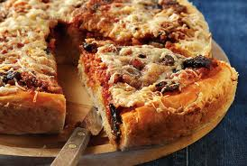](http://www.google.gr/imgres?hl=el&sa=X&tbas=0&biw=1920&bih=944&tbm=isch&tbnid=CuGcwZkvYhVsGM:&imgrefurl=http://www.argiro.gr/recipes/%CF%80%CE%AF%CF%84%CF%83%CE%B1-%CF%80%CE%AF%CF%84%CE%B1-%CE%BC%CE%B5-%CF%87%CF%89%CF%81%CE%B9%CE%AC%CF%84%CE%B9%CE%BA%CE%B1-%CE%BB%CE%BF%CF%85%CE%BA%CE%AC%CE%BD%CE%B9%CE%BA%CE%B1&docid=nRs_-g0LH4qxYM&imgurl=http://gr.liberis.argiro.production.s3-website-eu-west-1.amazonaws.com/images/712/n/pita-pizza.jpg?1291632828&w=622&h=419&ei=znaGULisJo7JswaLEg&zoom=1&iact=hc&vpx=362&vpy=309&dur=1410&hovh=184&hovw=274&tx=211&ty=80&sig=104790312333497293790&page=1&tbnh=138&tbnw=208&start=0&ndsp=41&ved=1t:429,r:9,s:0,i:90)

[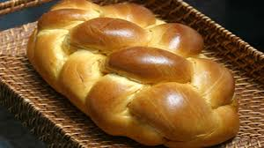](http://www.google.gr/imgres?hl=el&biw=1920&bih=944&tbm=isch&tbnid=gZ3LAznmPWhPEM:&imgrefurl=http://www.gourmed.gr/recipes/ZYMES-TSOYREKI-PARADOSIAKO-19399.htm&docid=9BPZ2a2znBgdYM&imgurl=http://www.gourmed.gr/filesbank/web/2011413212113_tsoureki%20cover.jpg&w=480&h=270&ei=pYCGULegBYz6sgb3_4H4CA&zoom=1&iact=hc&vpx=417&vpy=357&dur=1404&hovh=168&hovw=300&tx=168&ty=60&sig=104790312333497293790&page=1&tbnh=139&tbnw=251&start=0&ndsp=41&ved=1t:429,r:9,s:0,i:104)[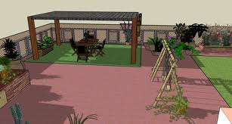](http://www.google.gr/imgres?hl=el&biw=1920&bih=944&tbm=isch&tbnid=Z34MJmJQMJw4lM:&imgrefurl=http://smartdeco2007.blogspot.com/2010/01/blog-post_18.html&docid=bm_s6Fs734AHPM&imgurl=http://3.bp.blogspot.com/_g_cQIihensY/S1TBhpPKEdI/AAAAAAAABKw/3ZER8Z3RmOk/s1600/AutoSave_AutoSave_1taratsa_2.jpg&w=1436&h=768&ei=IX-GUJPdFozAswaaw4DgAg&zoom=1&iact=hc&vpx=1034&vpy=614&dur=5811&hovh=164&hovw=307&tx=233&ty=90&sig=104790312333497293790&page=1&tbnh=139&tbnw=261&start=0&ndsp=38&ved=1t:429,r:6,s:20,i:144)[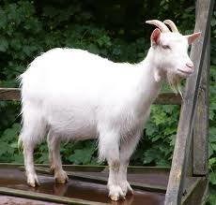](http://www.google.gr/imgres?hl=el&sa=X&tbas=0&biw=1920&bih=944&tbm=isch&tbnid=yG2L3Cr70EO4CM:&imgrefurl=http://anastasiag.pblogs.gr/2010/10/wto-stop-kai-h-katsika.html&docid=R3tzkA710wjoFM&imgurl=http://anastasiag.pblogs.gr/files/f/362370-ram-goat.jpg&w=478&h=455&ei=dH2GUM2tOcXcsgbFxoCgAg&zoom=1&iact=hc&vpx=545&vpy=141&dur=2000&hovh=219&hovw=230&tx=103&ty=115&sig=104790312333497293790&page=1&tbnh=147&tbnw=155&start=0&ndsp=44&ved=1t:429,r:2,s:0,i:69)[](http://www.google.gr/imgres?hl=el&biw=1920&bih=944&tbs=itp:clipart&tbm=isch&tbnid=QPHgBdIqsRbCyM:&imgrefurl=http://www.rr-naradi.cz/sekera-cerna-s-kvalitni-ceskou-bukovou-nasadou-1600g&docid=JX-S7LQNU5tRBM&imgurl=http://www.rr-naradi.cz/images/produkty/obr/sekera-cerna-s-kvalitni-ceskou-bukovou-nasadou-1400g-kopie.jpg&w=800&h=600&ei=LHyGUKWhGYj5sgbZt4HwDw&zoom=1&iact=hc&vpx=625&vpy=334&dur=506&hovh=194&hovw=259&tx=116&ty=111&sig=104790312333497293790&page=1&tbnh=144&tbnw=192&start=0&ndsp=46&ved=1t:429,r:12,s:0,i:103)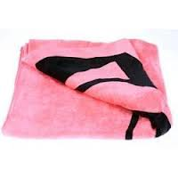[](http://www.google.gr/imgres?hl=el&biw=1920&bih=944&tbs=itp:clipart&tbm=isch&tbnid=beDf2fiJFY9ePM:&imgrefurl=http://pamsclipart.com/clipart_images/little_black_stick_girl_0515-0910-2423-5755.html&docid=yDGzAk6Qz437LM&imgurl=http://pamsclipart.com/clipart_images/little_black_stick_girl_0515-0910-2423-5755_SMU.jpg&w=300&h=300&ei=U3yGUMfCM4HOtAb5lIEQ&zoom=1&iact=hc&vpx=176&vpy=357&dur=789&hovh=225&hovw=225&tx=133&ty=84&sig=104790312333497293790&page=1&tbnh=141&tbnw=141&start=0&ndsp=60&ved=1t:429,r:12,s:0,i:117)

[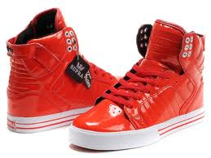](http://www.google.gr/imgres?hl=el&biw=1920&bih=944&tbm=isch&tbnid=qeNMYFd_kw8g8M:&imgrefurl=http://www.supraskytopaustralia.com/supra-skytop-i-shoes-men-sale-grey-p-497.html&docid=41bpyovWcy7zZM&imgurl=http://www.supraskytopaustralia.com/images/supra%20skytop%20i/53_supra_skytop_i_shoes_men_sale_red.jpg&w=640&h=480&ei=n4OGUJ2CL4SxtAbEp4GICA&zoom=1&iact=hc&vpx=741&vpy=637&dur=1214&hovh=194&hovw=259&tx=121&ty=166&sig=104790312333497293790&page=2&tbnh=135&tbnw=182&start=47&ndsp=57&ved=1t:429,r:50,s:20,i:355)[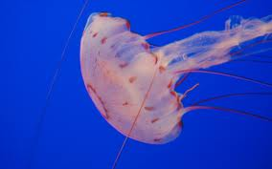](http://www.google.gr/imgres?hl=el&biw=1920&bih=944&tbm=isch&tbnid=MxVyeCWl6xiO0M:&imgrefurl=http://oktv.gr/ti-na-kanete-an-sas-tsimphsei-tsouxtra/&docid=eK5xv-HhIQ7I_M&imgurl=http://oktv.gr/wp-content/uploads/2012/08/%CF%84%CF%83%CE%BF%CF%85%CF%87%CF%84%CF%81%CE%B1.jpg&w=1600&h=1000&ei=FoOGUNy9DMbKsgb_xoCgCQ&zoom=1&iact=hc&vpx=759&vpy=157&dur=1346&hovh=177&hovw=284&tx=94&ty=92&sig=104790312333497293790&page=1&tbnh=137&tbnw=242&start=0&ndsp=42&ved=1t:429,r:3,s:0,i:72)